**The Ecological Footprint Quiz**

**Name: ________________________**

1. **HOME**

1. How many people live in your household?

POINTS

(a) 1 30

(b) 2 25

(c) 3 20

(d) 4 15

(e) 5 10

2. How is your home heated?

POINTS

(a) natural gas 30

(b) electricity 40

(c) oil 50

(d) renewable 0

(solar, wind)

3. How many individual faucets and toilets do you have in your home?

POINTS

(a) less than 3 5

(b) 3-5 10

(c) 6-8 15

(d) 9-10 20

(e) >10 25

**B. FOOD**

4. How many meals per week do you eat with meat or fish? POINTS

(a) 0 0

(b) 1-3 10

(c) 4-6 20

(d) 7-10 35

(e) >10 50

5. How many homemade meals do you eat per week (including those you bring to school or work)? POINTS

(a) under 10 25

(b) 10-14 20

(c) 15-18 10

(d) >18 10

6. When purchasing your food items, does your family try to buy locally-produced goods?

POINTS

(a) yes 25

(b) no 125

(c) sometimes 50

(d) rarely 100

(e) don’t know 75

**C. TRANSPORTATION**

7. If you or your family own vehicles, what type are they? Add points for each type of vehicle. POINTS

(a) motorcycle 15

(b) small-compact 35

(c) mid-sized 60

(d) full-sized 75

(e) SUV or van 100

(f) truck 130

8. How do you get to school/work? POINTS

(a) car 50

(b) public transit 25

(c) school bus 20

(d) walk 0

(e) bike or roller blade 0

9. How many trips do you make per week on public transit for which you would have otherwise used a car? POINTS

(a) 0 50

(b) 1-5 40

(c) 6-10 30

(d) 11-15 20

(e) >15 10

10. Where did you go on vacation in the last year? POINTS

(a) no vacation 0

(b) in the province 10

(c) another province 30

(d) to the US 40

(e) outside North America 70

11. How many summer weekend trips do you take by car? POINTS

(a) 0 0

(b) 1-3 10

(c) 4-6 20

(d) 7-9 30

(e) >9 40

**D. PURCHASES**

12. How many large purchases (eg., Stereo, TV, VCR, computer, car, furniture, etc.) has your household made in the past year?

POINTS

(a) 0 0

(b) 1-3 15

(c) 4-6 30

(d) >6 45

13. Have you bought any energy efficient products in the past year (eg., Light bulbs, fridges, stoves, toilets)?

POINTS

(a) yes 0

(b) no 25

**E. WASTE**

14. Does your household try to reduce the amount of waste created in the house (eg., buying food in bulk, refusing junk mail/flyers, using reusable containers for storage, using natural cleaners)?

POINTS

(a) always 0

(b) sometimes 10

(c) rarely 20

(d) never 30

15. Does your household compost?

POINTS

(a) always 0

(b) sometimes 10

(c) rarely 15

(d) never 20

16. Does your household recycle newspapers, cardboard/boxboard/pizza boxes?

POINTS

(a) always 0

(b) sometimes 10

(c) rarely 15

(d) never 20

17. How many garbage bags of waste do you set out for pick-up each week?

POINTS

(a) 0 0

(b) one, half-full 5

(c) 1 10

(d) 2 20

(e) >2 30

**Answer these questions on another sheet of paper and hand them in:**

1. How does your score compare to the Canadian average?

2. How does your score compare to the World average?

3. What are some things (2+) that you are doing well in keeping your footprint smaller?

4. What are some things (2+) that you are doing poorly and make your footprint bigger?

5. What are some SPECIFIC things (2+)that you WILL do to reduce your footprint now that you know what to do?

6. What are some other items that should be considered that were not addressed with this questionnaire?

7. Why/How is a questionnaire like this helpful if it doesn’t address all of the areas possible?

**What’s a Fair Earth share?**

Total your score by adding up the points from each question, and compare it to the following chart:

**Your Score Ecological Footprint (in Hectares):**

**(which is 10 000 m2 or nearly 2.5 acres)**

Less than 150 Less than 4.0

150-350 4.0-6.0

350-550* 6.0-7.7*

550-750 7.7-10.0

More than 750 More than 10.0

**\*the Canadian average**

**YOUR SCORE: __________**

**Ecological Footprint Ranking (1995)**

**Country Ecological Footprint**

**(hectares per person)**

United States 9.72

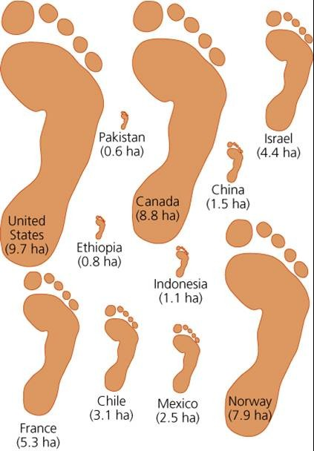**Canada 7.29**

Singapore 6.48

Hong Kong 6.08

Ireland 5.67

France 5.27

Iceland 4.86

United Kingdom 4.46

Italy 4.05

Portugal 3.65

Malaysia 3.24

Costa Rica 2.84

Mexico 2.43

**World Average 2.03**

Egypt 1.62

India 1.22

Bangladesh 0.41

http://www.wrsc.org/attach_image/ecological-footprint-breakdown-nation

